Exp No: 8
GAS SENSOR MQ-2 IN PROTEUS USING ARDUINO
AIM:
To write an Embedded C program for interfacing Gas Sensor MQ-2 using Arduino Uno and Proteus.
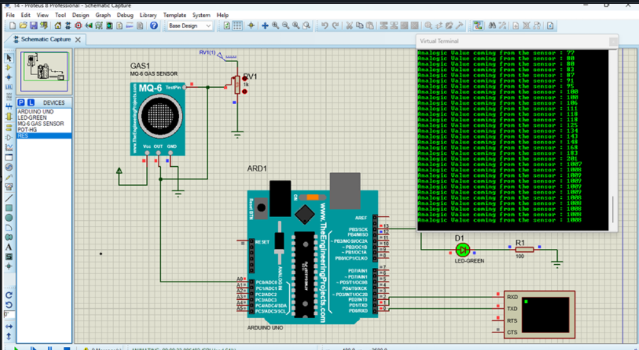
RESULT:
Thus the program has been successfully verified and executed.

